|  |  |  |  |  |
| --- | --- | --- | --- | --- |
| 17Month | Guest Amount | Cafeteria Amount | Payment  (paid or not) | Date of Payment |
| January | 1770 |  | paid | 21/06/2022 |
| February | 6485 |  | paid | 21/06/2022 |
| March | 11900 | 1930 | paid | 21/06/2022 |
| April | 64635 | 25962 | Paid75427  Rem 15170 | 21/06/2022 |
| May | 42199 | 20973 |  |  |
| June | 25959 | 21928 |  |  |
| July | 20010 | 13375 |  |  |
| August |  |  |  |  |
| September |  |  |  |  |
| October |  |  |  |  |
| November |  |  |  |  |
| December |  |  |  |  |

Statement of Dalaila

Photo of the cheque

29th march2022 Paid cheque of 100000

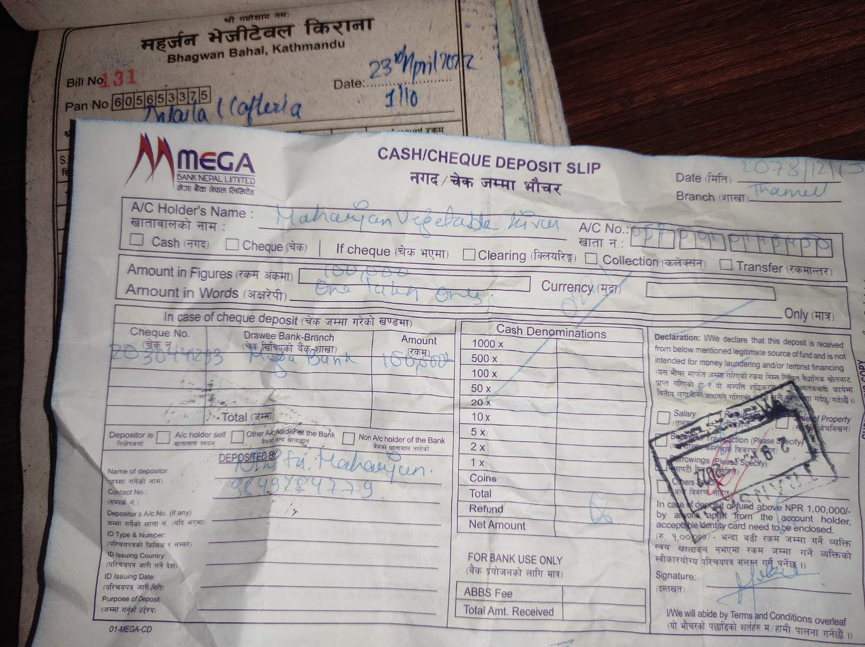

21st June 2022 AMT 150000

